Ecommerce Project

- Goal: Analyse the sales performance of products, categories, and regions.
- Database Schema Overview: We have 5 tables:
- Customers
- Products
- Orders
- OrderDetails
- Regions

Questions:
- General Sales Insights
  - What is the total revenue generated over the entire period?
QUERY
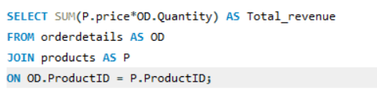
Ans -
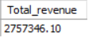
  - Revenue Excluding Returned Orders
QUERY
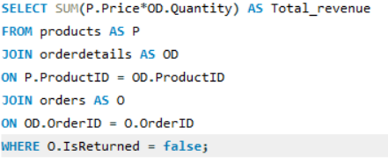
Ans -
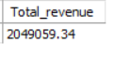

  - Total Revenue per Year / Month
QUERY (YEAR)
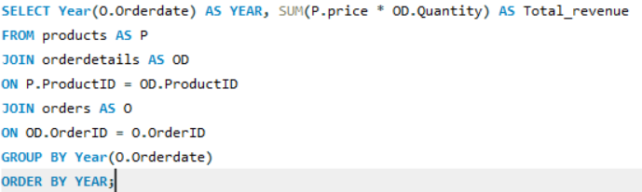
Ans -
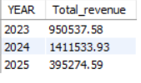

QUERY (MONTH)
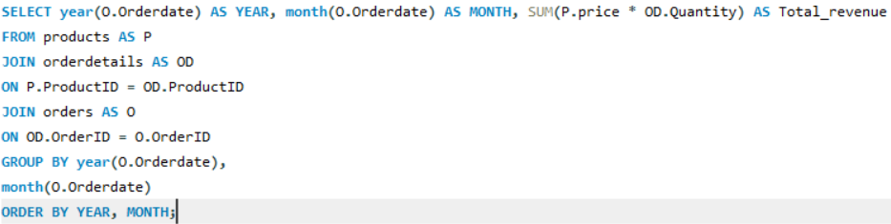

Ans -

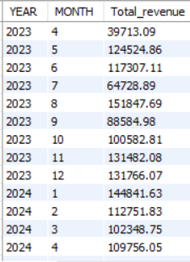
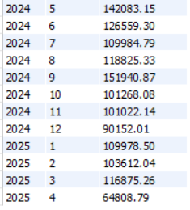

  - Revenue by Product / Category
QUERY
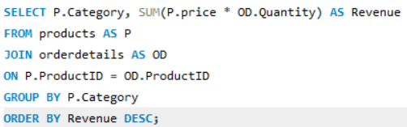
Ans -
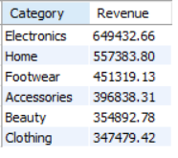

  - What is the average order value (AOV) across all orders?
QUERY
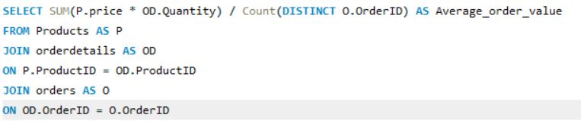
Ans -
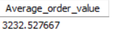

  - AOV per Year / Month
QUERY (YEAR)
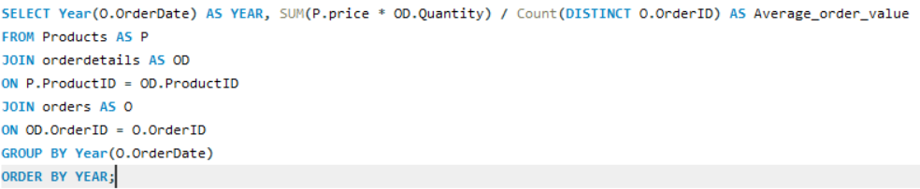
Ans -
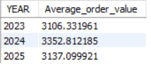
QUERY (MONTH)
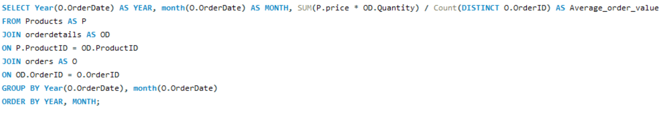
Ans -
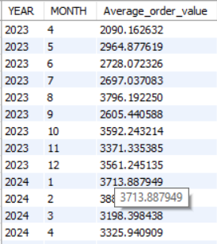
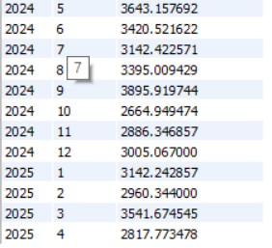
  - What is the average order size by region?
QUERY

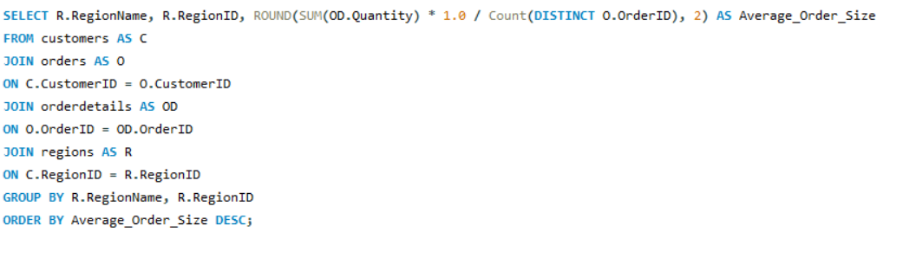
ANS -
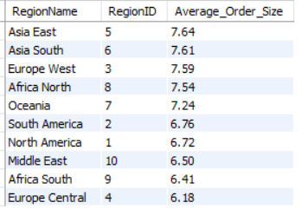
- Customer Insights
  - Who are the top 10 customers by total revenue spent?
Query
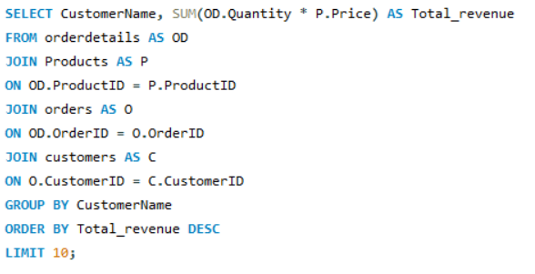
Ans -
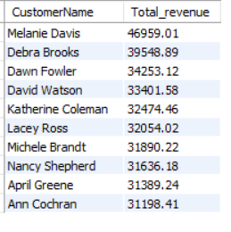
  - What is the repeat customer rate?
QUERY
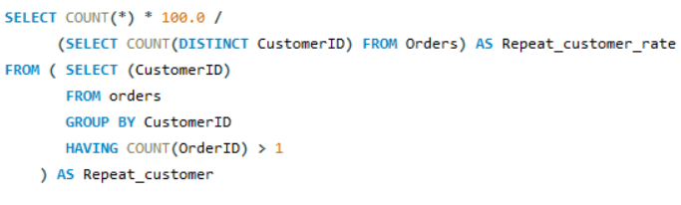
Ans -
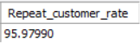
  - What is the average time between two consecutive orders for the same customer Region-wise?
QUERY
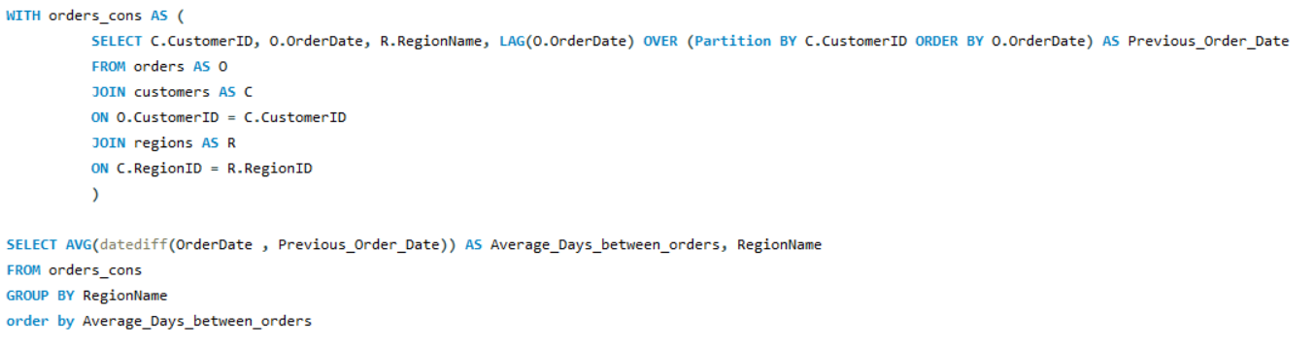
ANS -
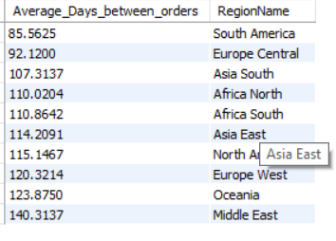

  - Customer Segment (based on total spend)
    - Platinum: Total Spend > 1500
    - Gold: 1000–1500
    - Silver: 500–999
    - Bronze: < 500
QUERY
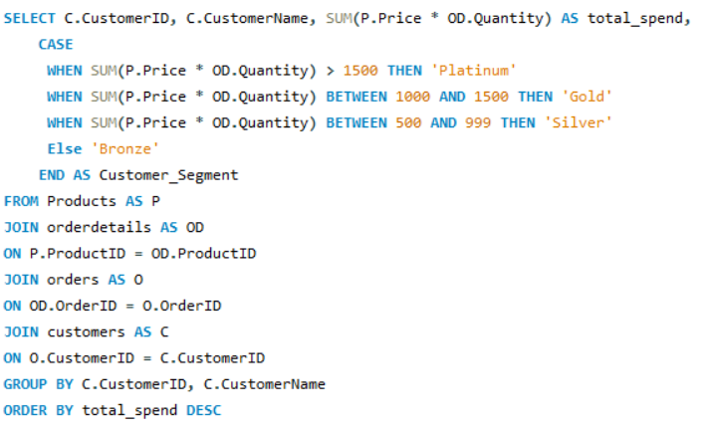
Ans -
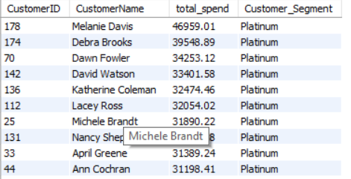
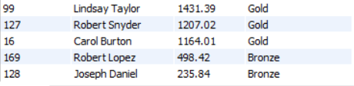

  - What is the customer lifetime value (CLV)?

QUERY
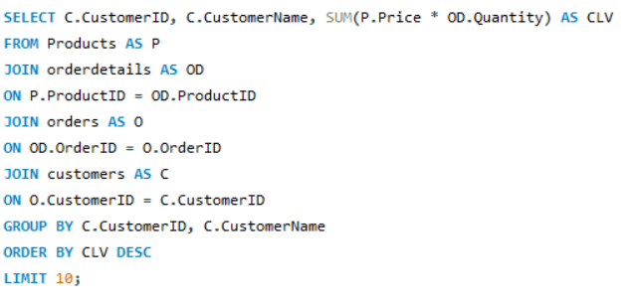
ANS -
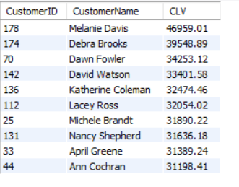

- Product & Order Insights
  - What are the top 10 most sold products (by quantity)?
QUERY
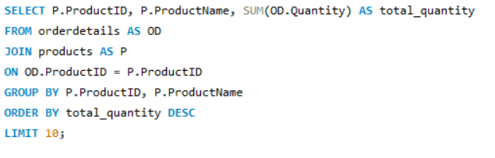

ANS -
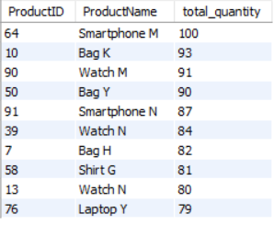
  - What are the top 10 most sold products (by revenue)?
QUERY
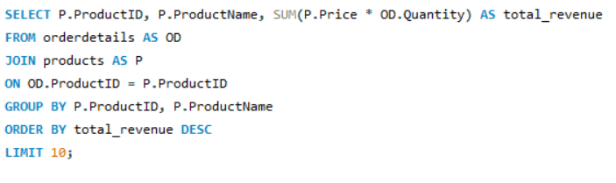
ANS -

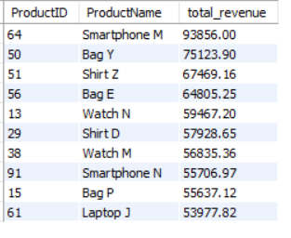

  - Which products have the highest return rate?
QUERY
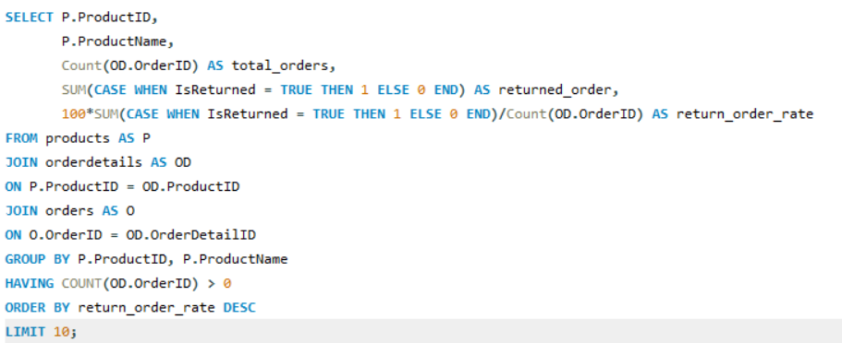
ANS -
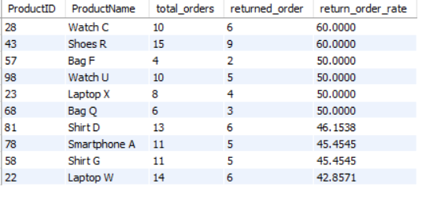

  - Return Rate by Category
QUERY
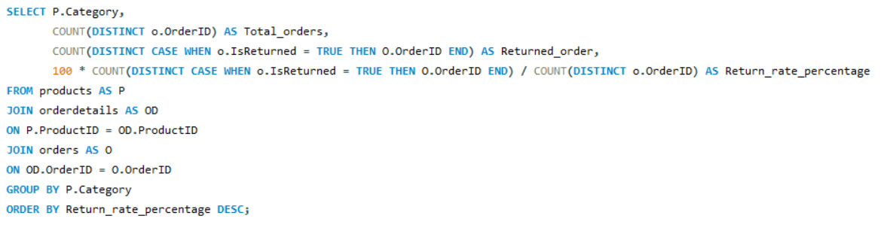

ANS -
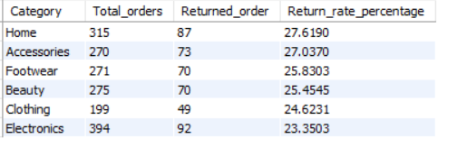

  - What is the average price of products per region?
QUERY
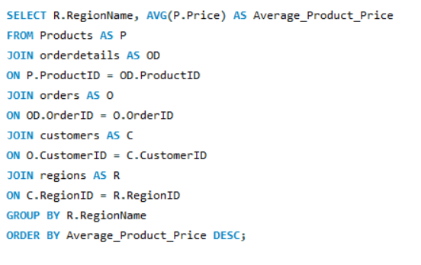

ANS -
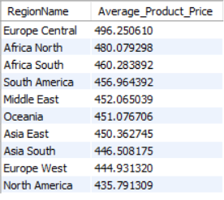

  - What is the sales trend for each product category?
QUERY
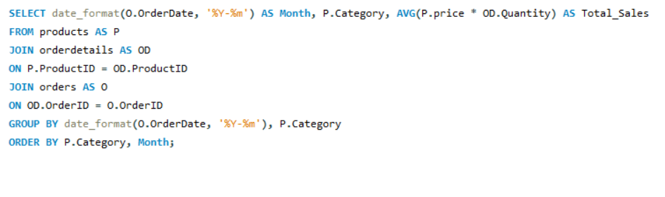
ANS -
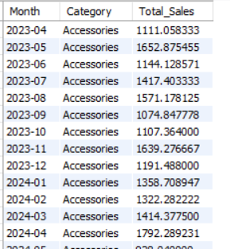 (OUTPUT has all 6 categories )

- Temporal Trends
  - What are the monthly sales trends over the past year?
QUERY
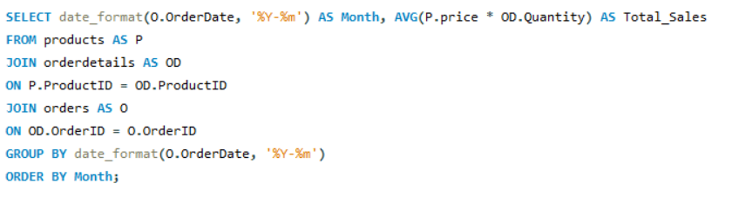
ANS -
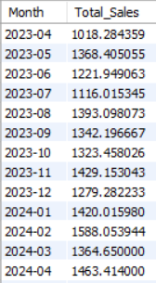
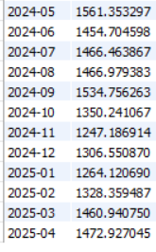
  - How does the average order value (AOV) change by month or week?
QUERY
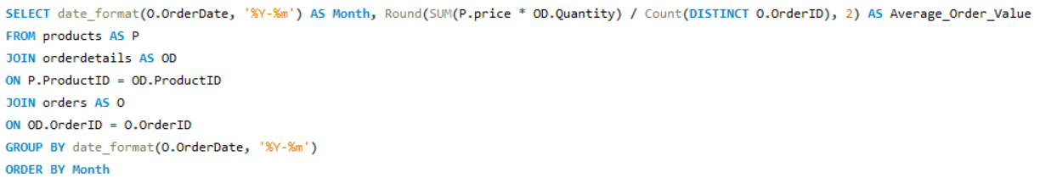
ANS -
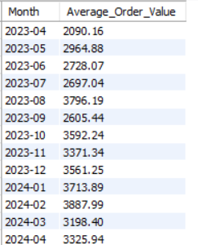
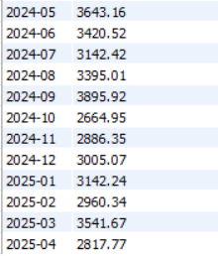

- Regional Insights
  - Which regions have the highest order volume and which have the lowest?
QUERY (Highest order_volume)
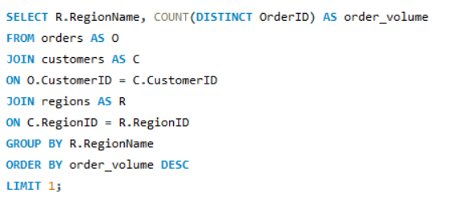
ANS -
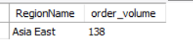
QUERY (Lowest order_volume)
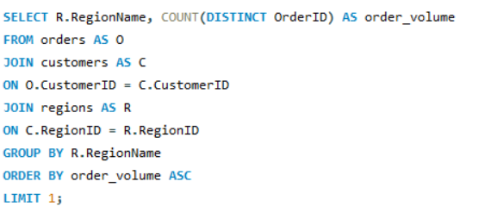
ANS -
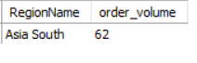
  - What is the revenue per region and how does it compare across different regions?
QUERY

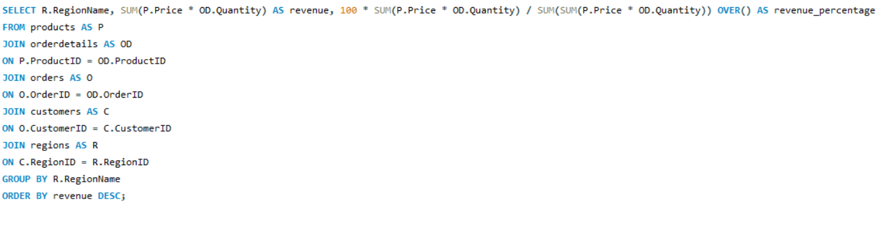
ANS -
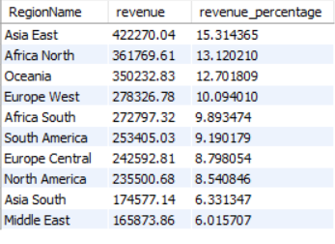

- Return & Refund Insights
  - What is the overall return rate by product category?
QUERY
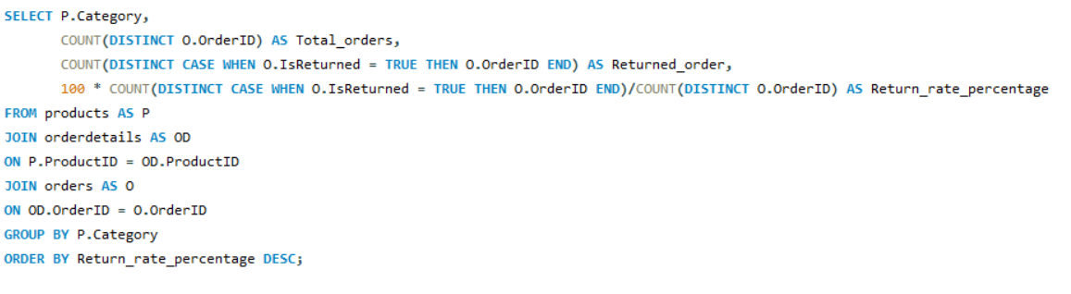
ANS -
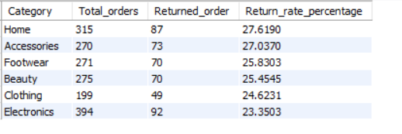
  - What is the overall return rate by region?
QUERY
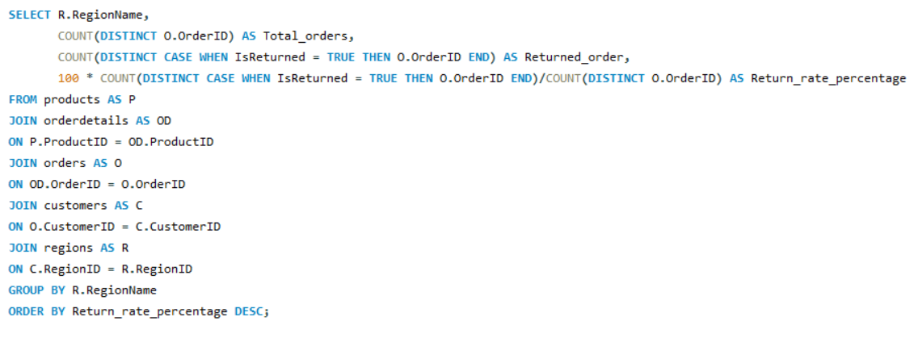
ANS -
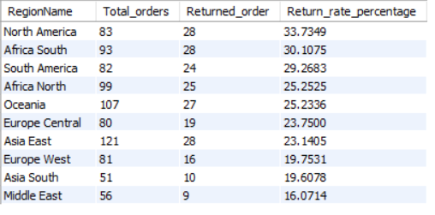
  - Which customers are making frequent returns?
QUERY
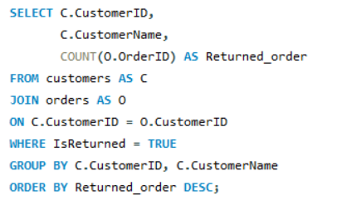
ANS -
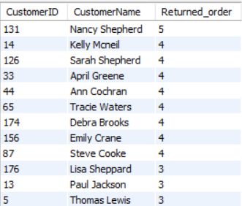
(Output has more Customer ID)

